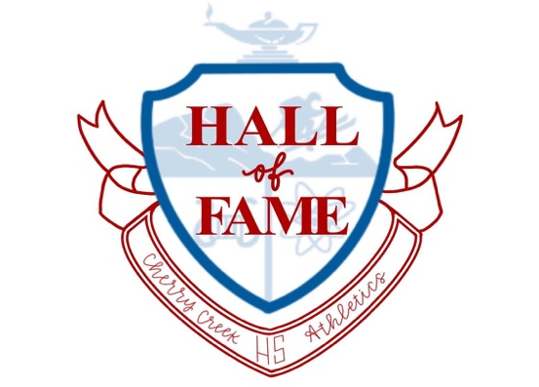

The Cherry Creek High School Hall of Fame is pleased to recognize, preserve, and honor athletes, coaches, and individuals who have made significant contributions to the school’s athletic programs. The **Third Class 2024** is pleased to select and recognize the following individuals who have distinguished themselves and whose accomplishments merit recognition.

Class of 2024 Cherry Creek High School Hall of Fame Inductees

Tom Tesone 1973 Football

1973-74 Girls Swimming Team 1973 1st State Championship Team

Coached by Judy Hilton

Marc Johnson 1973-2024 Boys Baseball Coach

1983 Boys Baseball Team 1983 1st State Championship Baseball Team Coached by Marc Johnson

Polly Kiker-Gilligan 1996 Girls Gymnastics

Alicia Salas 2000 Girls Tennis

Clare Gallagher 2010 Girls Cross Country

Tommy Jaeger 2011 Boys Soccer

Daryl Turner 2013 Boys Swimming

Lizzy Raben 2013 Girls Soccer

The Induction Celebration will be held Thursday, September 26, 2024, Cherry Hills Country Club, 4125 South University Boulevard, Cherry Hills Village, CO 80113, 5:00-9:00pm. Tickets are on sale for friends and supporters through the Athletic Office: 720-554-2462.

Nominate a future inductee here:

[Click here to nominate](https://docs.google.com/forms/d/1yvH1qaI-Zqf0Jz4FCKcmcWRmAVrTWMYgXZJawe9KjEo/edit)